NFC-IET UNIVERSITY, MULTAN



LAB REPORT

ICT (“Information & Communication Technology Fundamental”)

For the degree of bachelor science
In Computer Science

Session [2k24]

Name: SOWAIBA ARIF

Roll No: (2k24-BSCS-411)

Section: Y

Submitted To: Ms. FABIA HASSAN

Submitted By: SOWAIBA ARIF

18 October 2024

LAB 1

TYPING PRACTICE (TYPING TUTOR)

Typing practice can help you improve your typing skills in many ways, including:

- Accuracy:
Touch typing improves accuracy because you're familiar with the location of each letter on the keyboard. This means you'll make fewer mistakes and be able to correct them more quickly.
- Speed:
Regular typing practice can increase your typing speed and reduce errors. This can help you get more work done in less time.
- Productivity:
Improved typing skills can increase your productivity and save you time, energy, and effort.
- Multitasking:
Touch typing allows you to type without constantly looking at the keyboard, which can help you multitask more effectively.
- Focus:
Touch typing engages your brain in a way that can help you focus and be more aware of what you're typing. This can help improve your written English skills and spelling.
- Accessibility:
Touch typing can be an invaluable skill for people with disabilities, such as vision impairments.
- Keyboarding posture:
Typing practice can help you develop proper keyboard technique.

INTERNAL COMPONENTS OF COMPUTER (RECOGNITION AND UNDERSTANDING)

The internal components of a computer are the essential hardware parts that work together to execute tasks, process data, and manage various functions of the system. Here's an overview of the main internal components and their functions:

1. Central Processing Unit (CPU):
- Function: Often referred to as the "brain" of the computer, the CPU performs the majority of the processing tasks. It interprets and executes instructions from programs, manages data flow, and performs arithmetic and logic operations.
- Key parts:
  - ALU (Arithmetic Logic Unit): Performs all arithmetic and logical operations (e.g., addition, subtraction, AND, OR).
  - Control Unit (CU): Coordinates and controls the activities of the computer by directing the flow of data and instructions.
  - Registers: Small, fast storage locations used to hold data temporarily during processing.

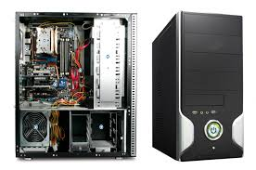

2. Motherboard:
- Function: The motherboard is the main circuit board that houses the CPU, RAM, and other essential components. It provides the physical and electrical connections between all internal components, such as expansion cards, storage devices, and the power supply.
- Key parts:
  - Chipset: Manages data flow between the CPU, memory, and peripheral devices.
  - Bus: A communication system that transfers data between the CPU, memory, and other devices.

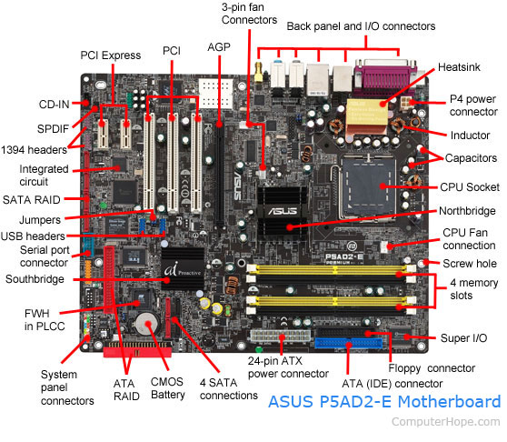

3. Memory (RAM):
- Function: Random Access Memory (RAM) is temporary storage that holds data and program instructions that are actively being used or processed by the CPU. It is much faster than secondary storage but is volatile, meaning data is lost when the power is turned off.
- Types of RAM:
  - Dynamic RAM (DRAM): Slower but more common, requires constant refreshing.
  - Static RAM (SRAM): Faster but more expensive

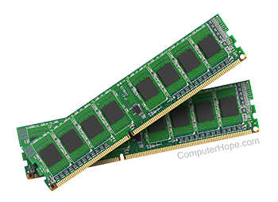

4. Storage Devices:
- Function: Permanent or long-term storage for data, files, operating systems, and applications.
- Types of Storage:
  - Hard Disk Drive (HDD): Magnetic storage that is slower but offers large storage capacity.
  - Solid State Drive (SSD): Faster and more durable than HDDs, but typically more expensive.
  - Optical Drives: Used for reading and writing to CDs, DVDs, or Blu-ray discs (less common today).

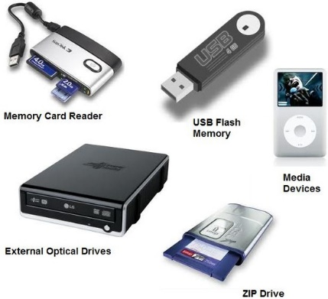

5. Power Supply Unit (PSU):
- Function: The PSU converts electrical power from an outlet (AC) into the appropriate low-voltage DC power required by the computer’s internal components.
- Important feature: It regulates and distributes power to the motherboard, CPU, RAM, and storage devices.

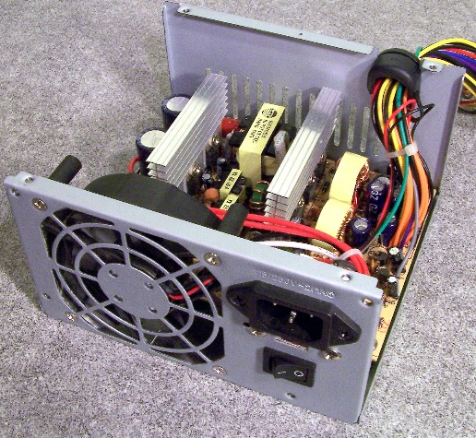

6. Graphics Processing Unit (GPU):
- Function: Also known as the video card or graphics card, the GPU handles rendering images, videos, and animations. It processes complex calculations for visual output, including 3D graphics, and is essential for gaming, video editing, and AI tasks.
- Key parts:
  - VRAM (Video RAM): A type of memory used by the GPU to store image and video data.
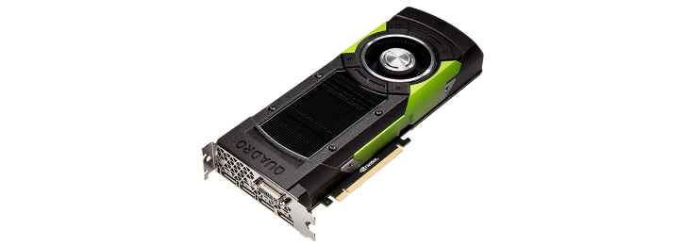

7. Cooling System:
- Function: Prevents internal components, particularly the CPU and GPU, from overheating by dissipating heat.
- Types:
  - Fans: Common for cooling the CPU and other components.
  - Heat sinks: Metal components that draw heat away from critical parts.
  - Liquid cooling: A more efficient method, often used for high-performance systems.

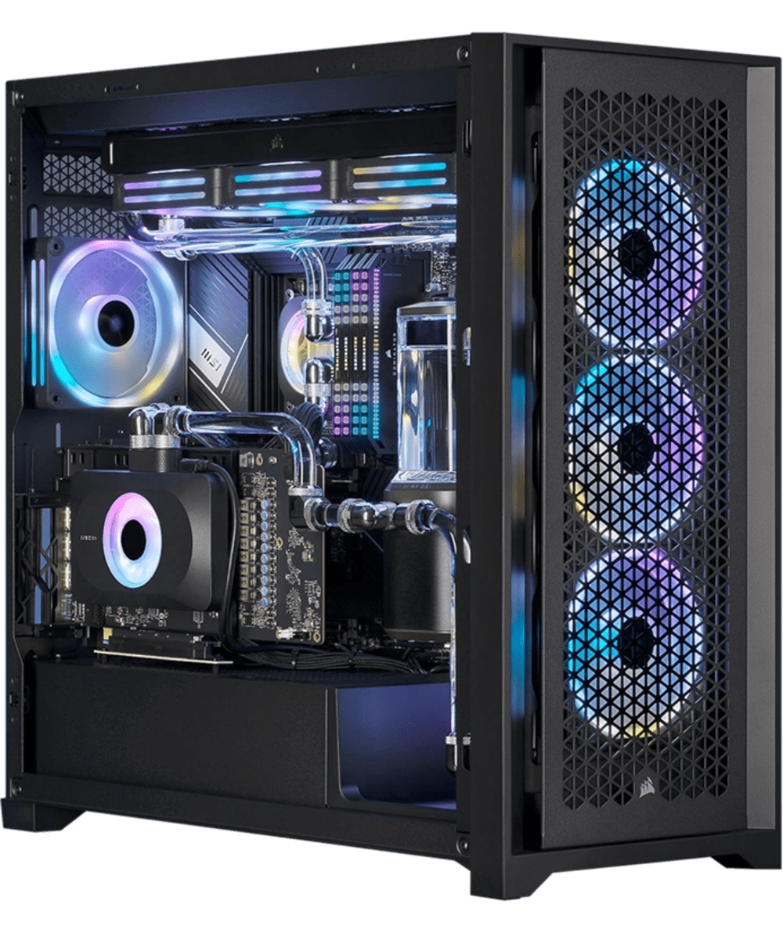

8. (I/O Ports):
- Function: These are the interfaces that allow external devices (such as USB drives, monitors, printers, and external storage) to connect with the computer.
- Types:
  - USB Ports: For connecting peripherals like keyboards, mice, printers, and storage devices.
  - HDMI: For connecting external monitors and displays.
  - Audio Jacks: For connecting speakers, microphones, or headphones.

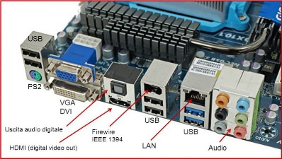

9. Bus System:
- Function: A set of communication pathways used to transfer data between different components inside the computer.
- Types:
  - Data Bus: Transfers the actual data.
  - Address Bus: Carries the addresses of where data should be read from or written to.
  - Control Bus: Sends control signals to coordinate operations between the CPU, memory, and other components.

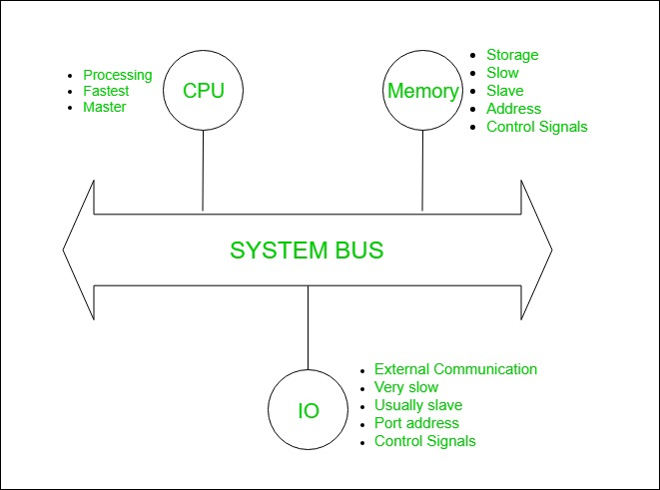

10. BIOS/UEFI (Basic I/O System / Unified Extensible Firmware Interface)
- Function: Firmware that initializes hardware during boot-up and provides a low-level interface between the operating system and the hardware. It allows the computer to start and load the operating system.
- BIOS: Older, traditional system firmware.
- UEFI: A newer standard with enhanced capabilities, including support for larger storage devices and secure boot features.

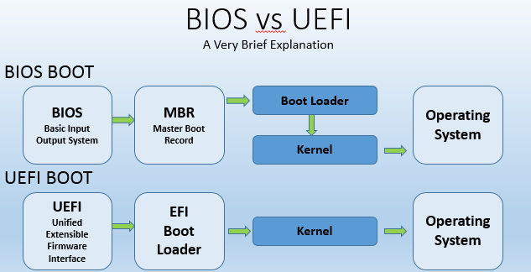

11. Cache Memory:
- Function: A small, fast memory storage located near the CPU that holds frequently accessed data and instructions, speeding up processing times by reducing the need to access slower RAM.
- Types:
  - L1 Cache: Closest to the CPU, extremely fast but small.
  - L2 Cache: Larger than L1, slightly slower.
  - L3 Cache: Shared among multiple CPU cores, larger and slower than L1 and L2.



12. Expansion Cards:
- Function: These are optional components that add additional functionality to the computer, such as sound, networking, or additional ports.
- Examples:
  - Sound card: Enhances audio capabilities.
  - Network Interface Card (NIC): Provides networking functions, including Wi-Fi or Ethernet.
  - USB Expansion Cards: Adds more USB ports.

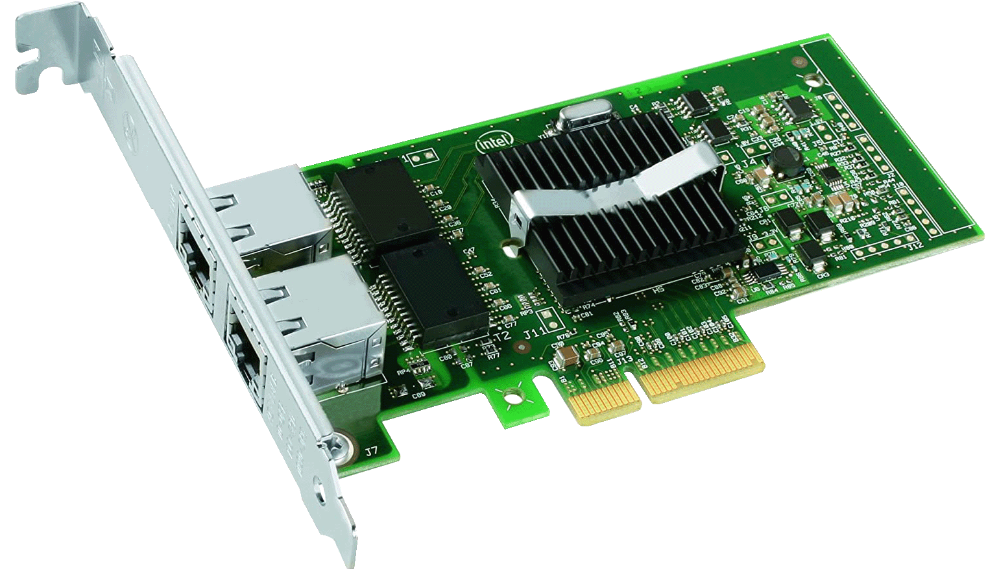

13. Peripheral Devices (External Components):
- Function: While not strictly internal, peripheral devices interface with the internal components of the computer and are essential for user interaction.
- Examples:
  - Keyboard and Mouse: Primary input devices.
  - Monitor: Primary output device.
  - Printer/Scanner: Input/output devices for physical data.

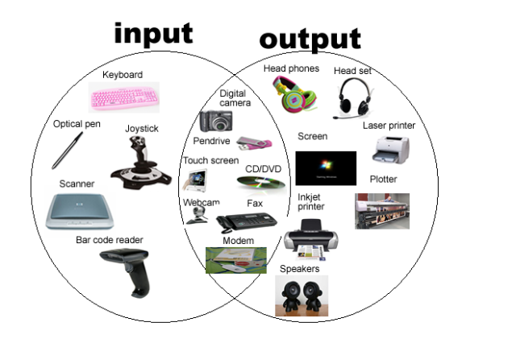
Top of Form

LAB 2

WINDOW INSTALLATION

WINDOW INSTALLATION STEPS:

Pre-Installation (Before Starting):

1. Measure window opening
2. Check for obstructions
3. Remove old window, trim, and debris
4. Inspect surrounding walls and framing
5. Prepare necessary tools and materials

Step 1: Prepare Opening:

1. Clean opening
2. Apply weatherproofing membrane (optional)
3. Install window sill
4. Secure sill with screws

Step 2: Assemble Window Frame:

1. Assemble frame components
2. Check frame for square
3. Secure frame corners

Step 3: Install Window Frame:

1. Place frame in opening
2. Secure frame to surrounding walls
3. Ensure proper alignment and level

Step 4: Install Window Sash:

1. Attach sash to frame
2. Add glazing (glass or other transparent materials)
3. Secure sash hinges and locks

Step 5: Add Insulation and Sealants:

1. Insulate gaps between frame and wall
2. Apply sealants (caulk, spray foam)
3. Ensure airtight seal

Step 6: Install Trim and Finishing Touches:

1. Install interior trim
2. Add exterior trim and flashing
3. Paint or finish trim

Step 7: Test and Final Inspection:

1. Test window operation

2. Verify proper installation

CPU ASSEMBLING

Assembling a CPU is part of the process of building a computer, which involves fitting all the internal components together so the computer can function. Here are some steps for assembling a CPU:

- Open the computer case by removing the back screws.
- Mount the motherboard.
- Align the processor with the copper-colored triangle on the CPU to the triangle or dot printed on the motherboard.
- Gently place the CPU into the socket so it rests on the pins.
- Install the CPU cooler

LAB 3

MOTHERBOARD AND ITS INTERNAL STRUCTURE

A motherboard is a printed circuit board (PCB) that's a key part of a computer system. It connects and supports many of a computer's most important components, including the central processing unit (CPU), memory, and input/output devices.
Here are some of the internal components of a motherboard:

- Base: A rigid, non-conductive material, like plastic, that forms the base of the motherboard
- Traces: Thin layers of copper or aluminum foil that are printed onto the base to form circuits between components
- Sockets and slots: Connect other components, such as the CPU, RAM, and expansion cards
- Chipsets: The Southbridge and Northbridge chipsets are part of a motherboard
- Cooling: A heat sink and fan assembly help keep the motherboard cool
- BIOS: The basic input/output system (BIOS) chip is part of the motherboard

LAB4

INTRODUCTION TO MS OFFICE

Microsoft Office (or simply Office) is a family of server software, and services developed by Microsoft. It was first announced by Bill Gates on August 1, 1988, in Las Vegas. The first version of Office contained Microsoft Word, Microsoft Excel, and Microsoft PowerPoint. Over the years, Office applications have grown substantially closer with shared features such as a common spell checker, data integration etc. Office is produced in several versions targeted towards different end-users and computing environments. The original, and most widely used version, is the desktop version, available for PCs running the Windows, Linux and Mac OS operating systems. Office Online is a version of the software that runs within a web browser, while Microsoft also maintains Office apps for Android and IOS. Microsoft Office is a suite of desktop productivity applications that is designed specifically to be used for office or business use. It is a proprietary product of Microsoft Corporation and was first released in 1990. Microsoft Office is available in 35 different languages and is supported by Windows, Mac and most Linux variants. It mainly consists of Word, Excel, PowerPoint, Access, OneNote, Outlook and Publisher applications.

MS WORD BASIC FEATURES

Microsoft Word is one of the most widely used word processing applications. Here are some of its basic features:

1. Document Creation and Editing
- Create New Documents: Start a blank document or choose from pre-designed templates.
- Text Editing: Type and modify text, including deleting, copying, cutting, and pasting content.
- Undo/Redo: Use the Undo and Redo buttons to reverse or reapply recent actions.
- Spell and Grammar Check: Word automatically checks spelling and grammar as you type, with options for suggestions and corrections.

2. Formatting Text
- Font Style & Size: Change font types, sizes, and colors to improve text readability or style.
- Bold, Italics, Underline: Apply these common formatting options to emphasize text.
- Text Alignment: Align text to the left, center, right, or justify (evenly spaced text).
- Text Highlighting: Highlight text using various colors.
- Text Case: Change text to uppercase, lowercase, or title case.

3. Paragraph Formatting
- Indentation: Adjust the indentation of paragraphs (left, right, or hanging indent).
- Line Spacing: Change the spacing between lines (single, 1.5, double spacing, etc.).
- Bullets and Numbering: Create bulleted or numbered lists.
- Borders and Shading: Add borders or shading to paragraphs for emphasis.

4. Page Layout
- Margins: Set the margins of the document (default, narrow, wide, or custom).
- Page Orientation: Choose between portrait (vertical) or landscape (horizontal) orientation.
- Page Size: Select different page sizes, such as A4, letter, legal, etc.
- Columns: Divide text into multiple columns for newsletters, reports, or brochures.

5. Inserting Objects
- Images: Insert pictures from your computer or online sources.
- Tables: Insert tables to organize data in rows and columns.
- Shapes: Add shapes like lines, circles, arrows, etc., to enhance your document.
- SmartArt: Insert pre-designed diagrams and charts for visual representation.
- Hyperlinks: Add links to external websites, email addresses, or specific sections of the document.
- Headers and Footers: Insert text, page numbers, and other information at the top or bottom of pages.

6. Working with Styles
- Built-in Styles: Apply predefined styles for headings, subheadings, normal text, and more.
- Custom Styles: Customize your own styles to maintain consistent formatting throughout the document.
- Theme: Apply a consistent color scheme, font style, and effects across your document.

7. Review and Collaboration
- Comments: Add comments for collaboration or personal notes.
- Track Changes: Enable the "Track Changes" feature to see edits made by others.
- Compare Documents: Compare two versions of a document and highlight the differences.
- Word Count: Count the number of words, characters, pages, or paragraphs in the document.

8. Printing and Saving
- Save and Save As: Save your document in different formats, including, .docx, .pdf, and more.
- Printing Options: Set up your document for printing, including page range, number of copies, and orientation.

9. Document Navigation
- Find and Replace: Quickly search for specific words or phrases, and replace them with other text.
- Go To: Navigate to a specific page, section, or line number within the document.
- Bookmarks: Create bookmarks to easily jump to different sections of a long document.

10. Headers, Footers, and Page Numbers
- Custom Headers/Footers: Add specific text or graphics to the header and footer sections, which appear on every page.
- Page Numbers: Insert automatic page numbering, or create custom page number formats.

11. Tables of Contents
- Automatic Table of Contents: Automatically generate a table of contents based on the headings in your document.

12. Document Protection
- Password Protection: Set a password to prevent unauthorized access to your document

LAB 5

MS WORD ADVANCED BASIC FEATURES

Microsoft Word offers several advanced features that help create professional, organized, and highly customized documents. Below are advanced basic features, including Mail Merge, Table of Contents, Section Breaks, References, and Headers/Footers.

1. Mail Merge
Mail Merge allows you to create personalized documents like form letters, invitations, or labels that are sent to a list of recipients. This is often used to send bulk correspondence (e.g., emails, letters) with customized information such as names, addresses, etc.

Steps to Use Mail Merge:
- Start the Mail Merge: Go to the "Mailings" tab, and click Start Mail Merge. Choose your document type (e.g., Letters, Envelopes, Labels).
- Select Recipients: Click Select Recipients and choose your data source (Excel file, Outlook contacts, etc.).
- Insert Merge Fields: Click Insert Merge Field to add placeholders such as the recipient’s name, address, or other personalized data into the document.
- Preview Results: Click Preview Results to see how the merged information looks.
- Complete the Merge: Once you're happy with the preview, click Finish & Merge to print the documents or create a new document with the merged data.

2. Table of Contents (TOC)
A Table of Contents provides an automatic, organized outline of the document, which is especially helpful for lengthy reports, books, or research papers.

Steps to Insert and Update a TOC:
- Apply Heading Styles: First, use built-in Heading Styles (Heading 1, Heading 2, etc.) to format your document’s headings and subheadings. This step is crucial because Word uses these headings to generate the TOC.
- Insert the TOC: Place the cursor where you want the TOC to appear. Go to the References tab, click Table of Contents, and choose a style from the available options (Automatic or Manual).
- Update the TOC: If you make changes to the document (e.g., adding more sections), right-click the TOC and select Update Field, then choose to update the entire table or just the page numbers.

3. Section Breaks
Section breaks allow you to divide a document into sections with different formatting, such as page orientation, headers/footers, or page numbering. This is useful for creating a document with varying formats, like having portrait orientation for some pages and landscape orientation for others.

Types of Section Breaks:
- Next Page: Starts a new section on the next page.
- Continuous: Starts a new section on the same page (useful for changing formatting like columns or spacing).
- Even Page/Odd Page: Starts a new section on the next even or odd page.

Steps to Insert Section Breaks:
- Place the cursor where you want the section break.
- Go to the Layout or Page Layout tab, click Breaks, and choose the type of section break you need.

4. References
The References tab in Word provides tools for adding citations, bibliographies, footnotes, endnotes, and more. This is useful for academic papers, research projects, and professional documents that require accurate referencing.

Key Features in the References Tab:
- Citations & Bibliography: Add and manage citations in a document by selecting Insert Citation. You can use various citation styles (APA, MLA, Chicago, etc.).
- Footnotes & Endnotes: Insert footnotes or endnotes to provide additional information or citations at the bottom of the page or at the end of the document.
- Table of Authorities: Automatically generate a list of legal authorities or references from your document.
- Cross-referencing: Link to other sections of the document (e.g., references to figures, tables, headings, or footnotes).

Steps to Add Citations and Bibliography:
- Insert Citation: Go to the References tab, click Insert Citation, and choose Add New Source to enter citation details.
- Insert Bibliography: After adding citations, place the cursor where you want the bibliography to appear, go to Bibliography, and choose a style

5. Headers and Footers
Headers and footers are used to display information at the top and bottom of every page (e.g., page numbers, document title, date, or author's name).

Steps to Use Headers and Footers:
- Insert a Header or Footer: Go to the Insert tab, and click Header or Footer to choose a built-in style or create a custom one.
- Different Headers/Footers for Sections: If you’ve used section breaks, you can have different headers/footers for each section. To do this, unlink the header/footer by deselecting Link to Previous in the Header & Footer Tools tab.
- Page Numbers: Insert page numbers in the header or footer by selecting Page Number in the Insert tab. You can choose from different locations and formats.
- Custom Text/Graphics: Add the document title, author’s name, or a logo to the header or footer. You can also insert the current date or time.

LAB 6

MENDELY (REFERENCE MANGEMENT AND CITATION TOOL)
Top of Form

MENDELY is a popular reference management and citation tool used by researchers, academics, and students to organize and manage their research papers, as well as to generate citations and bibliographies for academic writing. It helps users collect, organize, annotate, and share their research materials, making the process of writing research papers, theses, and articles more efficient.

Key Features of MENDELY:
- Reference Management: It allows you to collect and organize your references and research papers. You can store PDFs, articles, and other types of sources in your library, which can be tagged and categorized for easier searching.
- Citation Generation: It can automatically generate citations and bibliographies in various citation styles (e.g., APA, MLA, Chicago, etc.). This can save time when writing papers, as you don't need to manually format references.
- Collaboration: It provides a platform for collaboration, allowing users to share papers and collaborate with others on research projects. You can create groups to share research with colleagues or research communication

Step 1: Sign Up and Install
- Sign Up: Create a MENDELY account at www.mendeley.com.
- Download: Download and install MENDELY Desktop (or MENDELY Reference Manager) for your computer.

Step 2: Add References
- Drag and Drop PDFs: Drag PDF files into MENDELY, and it will try to extract citation details.
- Add Manually: If MENDELY doesn't capture the data correctly, add references manually (e.g., author, title).
- Web Importer: Install the MENDELY Web Importer extension for your browser and use it to save papers from online databases.

Step 3: Organize Your Library
- Create Folders: Organize references into folders by project or topic.
- Tag References: Add tags to references to make them easier to search.

Step 4: Annotate PDFs
- Highlight/Annotate: Open PDFs in MENDELY, use highlighting tools and add comments directly to the document.
- Sync: Sync your annotations across devices if you use MENDELY on multiple devices.

Step 5: Insert Citations in Word
- Install Word Plugin: Install the MENDELY plugin for Word (automatically installed with MENDELY Desktop).
- Insert Citations: In Word, click "Insert Citation" in the MENDELY toolbar to add citations while you write.
- Generate Bibliography: Click "Insert Bibliography" to create a reference list automatically.

Step 6: Sync Your Library
- Sync: Regularly sync your MENDELY library to keep everything backed up and accessible from any device.

Step 7: Share and Collaborate
- Create Groups: Start a group to share papers and collaborate with others.
- Share References: Share references with group members, and discuss the papers.

Step 8: Export References
- Export: Export your references in various formats (e.g. RIS) for use in other citation managers or software.

Top of Form

2. GRAMMALY (GRAMMAR AND WRITING ASISTANCE
Bottom of Form

Bottom of Form

Purpose:
- Improve Communication: Help individuals enhance their writing skills for clear and professional communication.
- Support Education: Provide resources for learning grammar, punctuation, and writing techniques.
- Foster Collaboration: Create a community of writers, educators, and linguists to share knowledge.
- Advocate for Standards: Set and promote high standards for grammar and writing in various fields.

Features:
- Grammar and Style Check: Automated grammar checker to spot errors in spelling, grammar, and punctuation.
- Educational Resources: Tutorials, workshops, and guides to help improve writing skills.
- Plagiarism Detection: Tools to check for originality and proper citation in writing.
- Writing Templates: Pre-made templates for common writing formats like essays, reports, and emails.
- Peer Review: Platform for sharing work and receiving feedback from the writing community.
- Personalized Writing Goals: Track writing progress and receive custom suggestions for improvement.
- Multilingual Support: Grammar and style assistance in multiple languages.
- AI Writing Assistance: AI-powered tools to suggest improvements and rephrase sentences.

Steps to Use GRAMMALY:
- Sign Up: Create an account to access services.
- Write or Upload Content: Start writing directly or upload an existing document.
- Grammar Check: The platform checks the document for errors.
- Review Suggestions: See and review suggestions for grammar, style, and structure improvements.
- Edit Content: Make revisions based on the suggestions provided.
- Access Resources: Use tutorials and guides for further writing help.
- Peer Feedback: Submit your work for feedback from other users.
- Download or Publish: Finalize your work and either download it or publish it online
Top of Form

PDF ELEMENT (PDF TO WORD CONVERSION TOOL)

Purpose:
- Convert PDF to Word: The main purpose of PDF Element is to provide users with a seamless tool to convert PDF documents into editable Word documents (.doc) without losing formatting.
- Edit PDFs Easily: Allow users to make edits to PDF documents after conversion, making them easier to work with.
- Improve Productivity: Enable fast, efficient document conversion for professionals, students, and businesses who frequently work with PDFs and need to edit or reuse the content in a Word format.

Features:
- PDF to Word Conversion: Effortlessly convert PDF documents into editable Word files while preserving the original layout, images, and formatting.
- Batch Conversion: Convert multiple PDF files to Word format at once, saving time and effort.
- OCR (Optical Character Recognition): Use OCR technology to convert scanned PDF documents (images or non-editable text) into fully editable Word files.
- Preserve Layout and Formatting: Maintain fonts, text, images, tables, and graphics during conversion.
- Easy Editing: After conversion, users can edit the Word document with familiar Word tools like Microsoft Word.
- Multiple Export Formats: Apart from Word, the tool also supports conversion to other formats like Excel, PowerPoint, HTML, and text.
- User-Friendly Interface: Intuitive interface that makes it easy for users of all technical levels to perform conversions quickly.
- Cloud Integration: Integration with cloud storage services like Google Drive, Dropbox for easy access to documents and sharing after conversion.

Steps to Convert PDF to Word Using PDF Element:
- Download and Install PDF Element: Install the PDF Element software on your computer (available for Windows and Mac).
- Open PDF Element: Launch the program after installation.
- Import PDF File: Click on "Open File" or drag and drop the PDF you want to convert into the PDF Element interface.
- Select the Convert Tool: Click on the “Convert” tab or option in the toolbar.
- Choose Word Format: Select “To Word” from the available output formats.
- Adjust Settings (Optional): You can choose to maintain the original layout, adjust OCR settings for scanned files, or select the pages you want to convert.
- Start Conversion: Click on "Convert" to begin the conversion process.
- Save the Word File: Once the conversion is done, select a location to save the newly created Word document. You can now open and edit the file in Microsoft Word or any Word processor.

AUTOMATING REPETITIVE TASKS WITH MACROS IN WORD

Purpose:
- Increase Efficiency: Macros allow users to automate repetitive tasks in Microsoft Word, saving time and effort on routine activities like formatting, data entry, or applying specific styles.

Steps to Create a Macro in Microsoft Word:
- Open Microsoft Word: Launch the Word application on your computer.
- Access the Developer Tab:
  - By default, the Developer tab is not visible in Word. To enable it:
    - Go to the File menu and click on Options.
    - In the Word Options window, select Customize Ribbon.
    - Check the box next to Developer in the right-hand column and click OK.
- Create a New Macro:
  - Go to the Developer tab that now appears in the Ribbon.
  - Click on Macros in the "Code" group.
  - In the Macros dialog box, enter a name for your macro .
  - Choose Store macro in to decide where to save the macro (e.g., in "All Documents (Normal.dotm)" for global use or "This Document" for use in just the current document).
  - Click Create to open the Visual Basic for Applications (VBA) editor.
- Record the Macro:
  - To automate actions, click Record Macro in the Developer tab (alternatively, press the Record Macro button in the Macros dialog).
  - Perform the sequence of actions you want to automate (e.g., changing font size, applying bold or italics, inserting text, etc.).
  - Once you’ve completed your actions, click Stop Recording on the Developer tab.
- Assign a Shortcut Key (Optional):
  - After recording, you can assign a keyboard shortcut to your macro for easy access:
    - In the Macros dialog, select your macro and click Options.
    - In the "Macro Options" box, assign a letter or key combination for quick use.
    - Click OK to save the shortcut.
- Run the Macro:
  - To run your macro, simply:
    - Go to the Developer tab, click Macros, select your macro from the list, and click Run.
    - Alternatively, use the assigned keyboard shortcut to trigger the macro instantly.
- Edit the Macro (Optional):
  - If you want to modify the macro, go to the Developer tab, click Macros, select the macro, and click Edit.

is omitted. 5.REFERENCING TOOLS FOR CITATION, FOOTNOTES, AND ENDNOTES

Purpose of Footnotes and Endnotes
Provide Source Attribution: Footnotes and endnotes are used to cite sources for a specific part of the text, allowing the reader to verify claims or find more information. They are especially helpful for citing books, articles, or other resources when you want to avoid disrupting the flow of your main content

Steps for Using Footnotes and Endnotes
Here are the steps for using footnotes and endnotes in the Chicago style, which is one of the most commonly used citation systems for footnotes:

1. Insert the Citation in the Text
- In the body of your document, place a superscript number at the end of the sentence or phrase where the citation or reference is needed.
- Example:
The theory of evolution has influenced modern biology significantly.^1

2. Create the Footnote or Endnote
- If you are using footnotes, the corresponding citation will appear at the bottom of the page.
- If you are using endnotes, the citations will be placed at the end of your document, after the main body of the text.

3. Format the Citation in the Footnote/Endnote
In Chicago style, the format for the first citation typically follows this structure:
Book:
- First Name Last Name, Title of Book (Place of Publication: Publisher, Year), page number.
Article:
- First Name Last Name, "Title of Article," Title of Journal Volume Number, Issue Number (Year): page number.
Example Citations:
- Book:
  - Charles Darwin, On the Origin of Species (London: John Murray, 1859), 45.
- Article:
2. Richard Dawkins, "The Extended Phenotype," Nature 300, no. 5892 (1982): 334.

4. Subsequent Citations (If Repeating a Source)
For subsequent references to the same source, Chicago style allows you to use a shortened citation after the first full citation.
Example:
- Darwin, On the Origin of Species, 50.

5. Formatting Notes
- Footnotes are generally numbered consecutively throughout the paper (starting with 1, 2, 3, etc.). The superscript number in the text corresponds to the note at the bottom of the page.
- Endnotes are numbered similarly but appear at the end of the document, after the conclusion or bibliography.
- In Chicago style, the footnotes/endnotes are single-spaced with a double space between each note.
- The first line of each note is aligned with the left margin; subsequent lines are indented (a hanging indented

Footnote vs. Endnote: Key Differences
- Footnotes appear at the bottom of the page where the citation or note is referenced, keeping the reader’s focus on the page.
- Endnotes are collected at the end of the document, which allows for a cleaner presentation of the text but requires the reader to flip to the end of the document to view the citation

LAB 7
Bottom of Form

MAIL MANAGEMENT
Bottom of Form

The purpose of mail management is to make email more usable, improve communication, and help you be more productive:
- Prioritize emails
Use an email management system to mark emails as high, low, or normal to help team members know what to work on first.
- Improve communication
Streamlined email communication can reduce delays, misunderstandings, and redundancy.
- Unsubscribe from unnecessary emails
Reduce the number of emails in your inbox by unsubscribing from irrelevant or unnecessary emails.
- Organize your inbox
Create folders for timely emails, informative messages, recurring projects, or by department.
- Improve security
Virtual mailboxes often offer encrypted platforms to protect your personal information and sensitive mail.
- Better work-life balance
Improved productivity and time efficiency can help you find more time for yourself and your family.

2. COLLABORATIVE TOOLS AND DOCUMENT PROTECTION (TRACK CHANGES AND COMMENTS FOR COLLABORATIVE WORK)

Document collaboration refers to the process of multiple people working together on a single document or set of documents. This can involve real-time editing, sharing feedback through comments, or managing different versions of a document to ensure that the most current information is being used.

1. Google Workspace:

Key features: Google Workspace offers real-time collaboration on documents, spreadsheets, and presentations. It integrates seamlessly with Gmail and Google Drive, providing a comprehensive suite for productivity.
Pricing: Starts at $6 per user per month.
Pros:
- Easy to use
- Excellent integration with other Google services
- Strong collaboration features
Cons:
- Limited advanced features compared to some competitors

2. Microsoft 365:

Key features: Microsoft 365 includes Word, Excel, PowerPoint, and One Drive, with robust collaboration features like co-authoring and SharePoint integration.
Pricing: Starts at $6 per user per month for the Business Basic plan.
Pros:
- Familiar interface
- Strong enterprise features
- Excellent security options
Cons:
- Can be overwhelming for new users
- Higher cost for advanced features

Slack:

Key features: While primarily a communication tool, Slack offers document collaboration through integrations with Google Drive, Microsoft Office, and other apps. It excels at keeping all discussions about a document in one place.
Pricing: Free for basic use, with paid plans starting at $6.67 per user per month.
Pros:
- Excellent for communication and collaboration
- Easy to integrate with other tools
- Highly customizable
Cons:
- Document editing isn’t native
- Can become cluttered without proper management

4. Dropbox Paper:

Key features: Dropbox Paper offers a simple, clean interface for document collaboration, focusing on real-time editing and commenting. It integrates well with Dropbox’s file storage, making it easy to manage documents and related files in one place.
Pricing: Free for individual use; business plans start at $12.50 per user per month.
Pros:
- Clean and intuitive interface
- Strong integration with Dropbox
- Supports multimedia content
Cons:
- Limited features compared to other tools
- Best suited for existing Dropbox users

Quip:

Key features: Quip, a Salesforce product, combines documents, spreadsheets, and communication in one tool. It’s designed for teams that need to work closely together on documents and projects, offering strong collaboration features and integrations with Salesforce.
Pricing: Starts at $10 per user per month.
Pros:
- Seamless Salesforce integration
- Combines documents and chat in one tool
- Strong collaborative features
Cons:
- Expensive for smaller teams
- Limited outside of the Salesforce ecosystem

ZOHO WORK DRIVE

Key features: It is an online file storage, sync, and collaboration platform designed for modern teams, small businesses, and large enterprises. It introduces Team Folders, which enable teams of any size to work together securely as if they were in the same room. It also includes the ZOHO Office Suite Editors for document creation and editing, comprehensive access statistics at both the team and Team Folder levels, and mobility features through Android, IOS mobile apps, and a desktop sync application.
Pricing: Free for up to 5 users; paid plans start at $2.50 per user per month.
Pros:
- Affordable pricing
- Team Folders for secure and efficient collaboration
- Mobile apps and desktop sync for on-the-go access
Cons:
- Best suited for existing ZOHO ecosystem users
- Some users may find the interface less intuitive compared to other tool

MASTER REVIEWING AND COMPARING DOCUMENT

The purpose of master reviewing and comparing documents is to ensure accuracy, consistency, and completeness of the content by evaluating different versions or related documents against each other. Here are key objectives of this process:
- Quality Control: By reviewing and comparing documents, errors or inconsistencies in content, formatting, and style can be identified and corrected. This helps in maintaining high-quality standards in the final document.
- Ensuring Consistency: When multiple versions of a document or related documents are involved, the comparison ensures that all parts align and are consistent in terms of data, language, and intent.
- Identifying Changes: Comparing documents allows for tracking revisions, updates, or changes made over time. It helps in identifying what's new, what has been removed, or what has been altered between versions.
- Preventing Redundancy: Master reviewing can help eliminate duplicated content or conflicting information that might have crept into the document, improving its clarity and flow.
- Improving Collaboration: In team-based or multi-author environments, comparing documents ensures that the contributions are integrated cohesively and any overlapping or contradictory sections are addressed.
- Ensuring Compliance: For legal, technical, or regulatory documents, reviewing and comparing ensures that all necessary standards, laws, or guidelines are adhered to and that no crucial information
- Final Approval and Sign-off: Before finalizing or publishing a document, it is essential to have a master review to confirm that all feedback has been incorporated, and the document is ready for distribution or submission.

PROTECT DOCUMENT WITH PASSWORD AND CONTROL EDITING PERMISSION

The purpose of protecting a document with a password and controlling editing permissions is to limit who can access the document and how they can interact with it:

- Prevent unauthorized access: Only people with the correct password can open and view the document.
- Control how users interact with the document: You can specify what users can do with the document, such as entering data, inserting hyperlinks, or sorting data.
- Protect sensitive information: You can prevent others from copying the content to a new file, changing the layout, or printing copies.

Here are some ways to protect a document:

- Password protection: You can apply a password to a document in Word by going to File > Info > Protect Document > Encrypt with Password.
- Read-only: You can save a document as read-only so that users can only read it, unless they save it with a different file name or location.
- Workbook-level protection: You can control how users work with worksheets in a workbook.
- Worksheet-level protection: You can control how users work with individual worksheets.
- File encryption software: You can use file encryption apps to encrypt individual

LAB 8

INTRODUCTION TO EXCEL AND BASIC SKILLS

  - Getting Started with Excel:
- A spreadsheet tool used for data entry, analysis, and visualization.

- Workbook & Worksheets:
Files with multiple sheets.
- Excel Interface:
Ribbon, Quick Access Toolbar, Formula Bar, and Status Bar.
- Create a New Workbook:
File → New → Blank Workbook
- Save Your Work:
File → Save As

  - Intermediate Formulas & Functions:
- Add/Delete Sheets:
Click "+" or right-click tab → "Delete"
- Rename Sheets:
Double-click the tab name.
- Link Data Across Sheets:
Use =Sheet2! A1 in formula.

Function | Description | Example
=MIN(range) | Finds the smallest value | =MIN(A1:A10)
=MAX(range) | Finds the largest value | =MAX(A1:A10)
=COUNT(range) | Counts numbers only | =COUNT(A1:A10)
=IF(condition, true, false) | Conditional check | =IF(A1>50, "Pass", "Fail")

. Cell Referencing Basics:

- Relative Referencing:
  - Adjusts automatically when copied.
- Example:
=A1+B1
- Absolute Referencing:
  - Fixed using $ symbol.
- Example:
=$A$1+$B$1

- Mixed Referencing:
  - Combines both methods.
- Example:
=$A1+B$1
Top of Form

4. Sorting & Filtering Data:
- Steps to Sort:
  - Select your data range.
  - Click Data → Sort.
  - Choose columns, sort by ascending/descending.
- Steps to Filter:
  - Select data range.
  - Click Data → Filter.
  - Use drop-down arrows to filter specific values.

LAB 9

Creating Charts and Graphs:
- Make data easier to interpret.
- Identify trends, patterns, and comparisons visually.

Popular Excel Chart Types:
- Bar Chart:
Compare categories side by side

IN CANVA WE CAN CREATE A BIRTHDAY CARD:
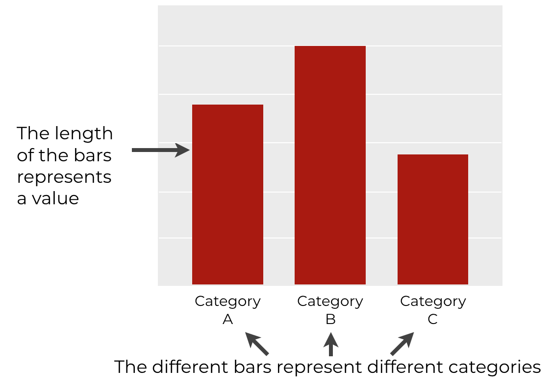
- Line Chart:
Show trends over time.
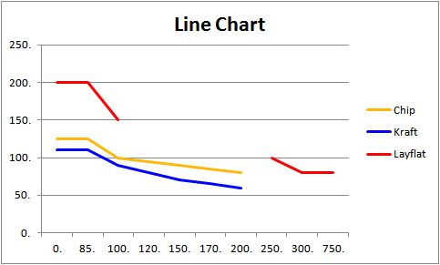
- Pie Chart:
Display proportions as slices of a circle.
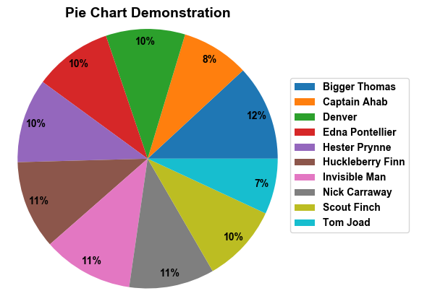

How to Create a Chart:
- Select your data range.
- Click Insert → Charts from the Ribbon.
- Choose your chart type (Bar, Line, Pie).
- Customize titles, legends, and labels.

2. Conditional Formatting:
Highlight important data visually by applying colors, icons, or bars based on conditions.

How to Apply Conditional Formatting:
- Select the data range.

2. Go to Home → Conditional Formatting.
3. Choose a rule (e.g., "Highlight Cells Greater Than").
4. Set your desired formatting style (color, bold text, data bars, or icons).

Example Rules:
- Sales Targets:
Highlight sales over $5,000 in green.
- Top Performers:

3. Creating Barcodes and QR Codes:
- Automate product tracking, inventory management, or event registration.

How to Create Barcodes and QR Codes:
- For Barcodes:
1. Install Code 39 Font or similar.
2. Enter the product ID and apply the barcode font.

- For QR Codes:
Go to Insert → Get Add-ins.
Search and install QR4Office.
Generate QR codes by entering data directly.



Working with Tables and Data Validation:
- Organize and format data efficiently.
- Enable filtering, sorting, and automatic formulas.

How to Create a Table:
- Select the data range.
- Click Insert → Table.
- Check “Table has headers” if applicable.

Applying Data Validation:
- Ensure only specific types of data are entered.
Steps:
- Select the target cells.
- Go to Data → Data Validation.
- Choose the validation type (e.g., list, whole number, or date).
- Customize the error message if needed.
- Example Use Cases:
- Dropdown Menus:
Create dropdown lists for selection.
- Input Restrictions:
Limit age to numbers between 18-60.
📸 Suggested Visual:
A well-formatted Excel table with dropdown lists and data validation alerts.

5. Statistical Analysis Functions:
Function | What It Does | Example
=AVERAGE(range) | Calculates the average value. | =AVERAGE(A1:A10)
=MEDIAN(range) | Finds the middle value. | =MEDIAN(A1:A10)
=MODE.SNGL(range) | Returns the most common value. | =MODE.SNGL(A1:A10)
=STDEV.P(range) | Standard deviation (pop.). | =STDEV.P(A1:A10)
=VAR.P(range) | Variance of a population. | =VAR.P(A1:A10)
=COUNTIF(range) | Counts values matching criteria. | =COUNTIF(A1:A10, ">50")
- Perform data analysis and generate insights quickly.

Key Excel Statistical Functions:

6. Frequency Function for Data Analysis:

- Analyze how often specific values appear in a dataset.

How to Use FREQUENCY Function:
- Enter data values in A2:A11 (e.g., exam scores).
- Define intervals (bins) in B2:B5 (e.g., 0-50, 51-70, etc.).
- Use this array formula (Ctrl + Shift + Enter):

=FREQUENCY (A2:A11, B2:B5):

Result:
The result shows how many scores fall within each bin range.

LAB 10
📊 Advanced Tools and Final Project in Excel:

1. Introduction to Pivot Tables

- Summarize, analyze, and explore data quickly.
- Create customized reports without altering the original data.

How to Create a Pivot Table:
- Select your data range.
- Go to Insert → Pivot Table.
- Choose where to place the table (New/Existing worksheet).
- Drag fields to Rows, Columns, Values, and Filters.

Example Use Case:
- Sales Report Analysis: Summarize total sales by month, region, or product.

- Using VLOOKUP and HLOOKUP:
- VLOOKUP: Finds data vertically in a column.
- HLOOKUP: Searches horizontally in a row.
VLOOKUP Syntax:
- excel
- Copy code

- =VLOOKUP(lookup_value, table_array, col_index_num, [range_lookup])
- Example:
Find a product's price from a product list:

Product | Price ($)
Laptop | 1000
Phone | 800
- Formula:
- =VLOOKUP("Laptop", A2:B4, 2, FALSE)
- Result: $1000

- HLOOKUP Syntax:
- =HLOOKUP(lookup_value, table_array, row_index_num, [range_lookup])

- Example:
Find the sales in March from a table:

Month | January | February | March
Sales ($) | 5000 | 7000 | 6500
- Formula:
- =HLOOKUP("March", A1:D2, 2, FALSE)
- Result:
- $6500

- Introduction to Macros:

🔹 Why Use Macros?
- Automate repetitive tasks.
- Increase productivity and reduce manual errors.

How to Create a Macro:

- Go to Developer → Record Macro.
- Name the macro and choose where to store it.
- Click Stop Recording.

Running a Macro:
- Use Alt + F8 or assign the macro to a button.

Example Task Automation:
- Format a report automatically (adjust font, add headers, apply styles).

- Final Project: Analyze and Visualize Data Set:

🔹 Project Goal:
Use the skills learned throughout the course to analyze and visualize a real-world dataset.
💡 Project Idea:
Sales Data Analysis Project:
- Data Source:
Use sales data (products, prices, regions, and sales amounts).
- Tasks:
  - Create a Pivot Table summarizing sales by region.
  - Use VLOOKUP to fetch product details.
  - Apply Conditional Formatting to highlight high sales.
  - Generate Charts: Bar, Line, and Pie Charts.
  - Create a Dashboard combining Pivot Tables and Charts.
  - Automate report generation with Macros.

IN CANVA WE CAN CREATE A BIRTHDAY CARD:


